**LPS3 Quick Reference Cards**

Selecting an Order 4

The Setup Menu 5

The Station Menu 7

Dashboard 7

Document Viewer 9

Quick Reference Guide 10

Viewing Documents 11

Using the Document Viewer 12

Scanning Coils 13

Scanning Dies 14

Entering Scrap 15

Completing Setup 17

Cancelling the Job 19

Entering Cycles 20

The Production Menu 21

Selecting the Next Order 23

Creating Bins 24

Auditing Scrap 26

Completing Production 27

The Teardown Menu 28

Viewing Work Orders 29

Working with Tasks 30

Completing Teardown 31

Completing Work Orders 32

Working with Assigned Tasks 33

Adding Tasks 34

Closing a Work Order 35

Adding a Work Order 36

Managing Bins 37

Creating a Bin 39

Moving Parts between Bins 40

Adjusting Bin Size and State 42

Printing a Bin Label 44

Entering Bin Scrap 45

Entering Loose Scrap 46

# The Idle Menu

The ***Idle Menu*** is the starting point for selecting orders. It has two possible menu options:

* 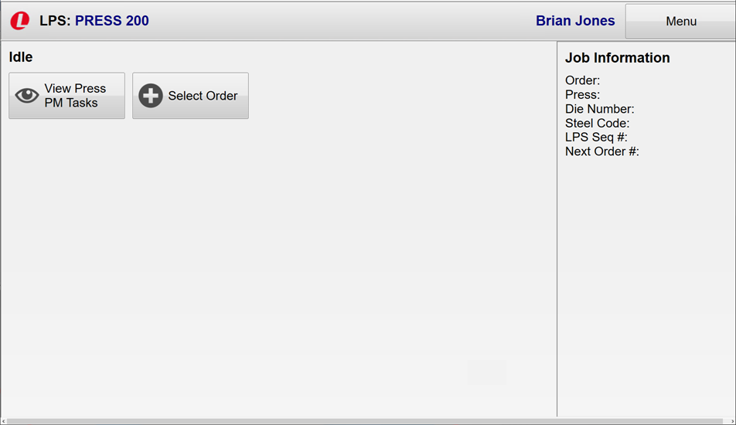View Press PM Tasks
* Select Order

# Viewing Press PM Tasks

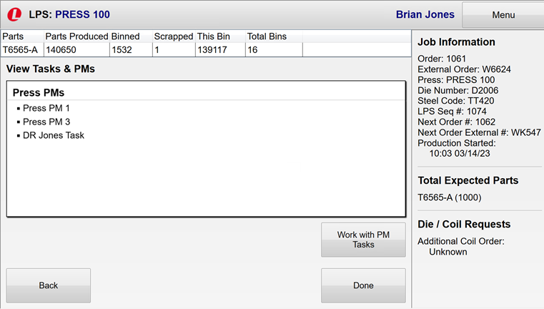This menu option enables you to view and manage preventative maintenance tasks for the press.

To change a PM task status:

1. Touch **Work with PM** Tasks.

The ***View Press PM Tasks*** view is returned. Current tasks are displayed in the color representing the task status.

1. Touch a task to toggle its status.

Options are:

* + Pending
  + 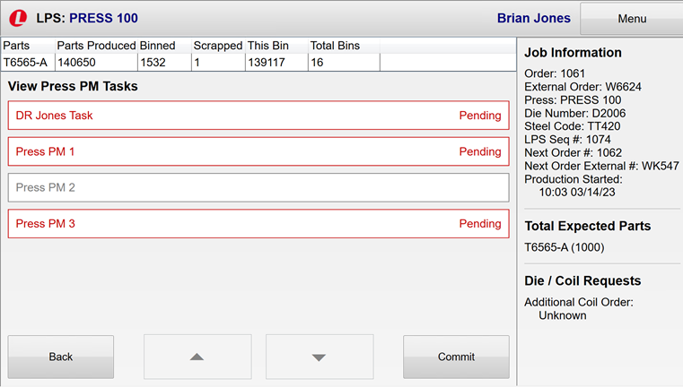Completed
  + Overridden

1. Touch **Commit** to save your entries.
2. Click **Done** in the ***View Tasks & PMs*** view to   
   return to the menu.



# Selecting an Order

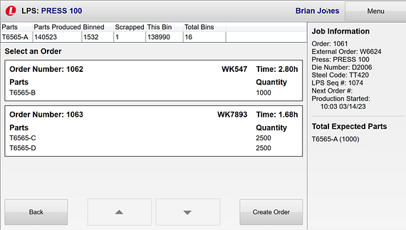The first step in controlling the station is to select an order to process.

1. Touch the **Select Order** button in the ***Idle*** menu.

The ***Select an Order*** screen displays orders waiting to be processed.

Each order includes:

* + Order number
  + Parts created
  + 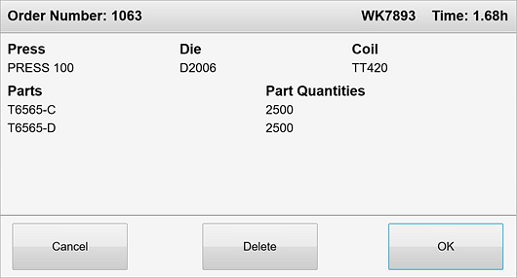Plant
  + Production time needed
  + Quantity to produce for each part

1. Touch an order.
2. The ***Order Number*** pop-up screen is displayed.
3. Click **OK** to create the job. The ***Setup*** menu is returned.

**1**

**2**

**4**

# The Setup Menu

The ***Setup***menu is displayed after you select and verify an order (by clicking **OK** in the ***Order Number*** pop-up window). Actions available from this menu allow you to prepare the station for the job. The following options may be visible:

View Press PM Tasks

Edit Job

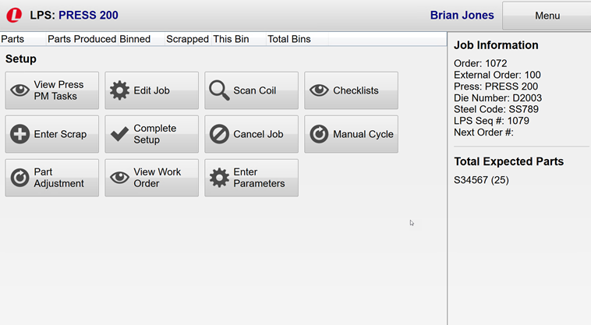Scan Coil

Checklists

Enter Scrap

Complete Setup

Cancel Job. Touch here to cancel the job. **Authorized personnel only will have access to this button. button.**

Manual Cycle. Touch here to enter the number of cycles that have been completed.

This panel displays job details as a visual reminder of what will be produced. The information is the same as seen in the ***Order Number*** pop-up window plus an LPS Sequence number.

Part Adjustment

View Work Order. Touch here to view any tasks or preventive maintenance that must be performed.

Enter Parameters

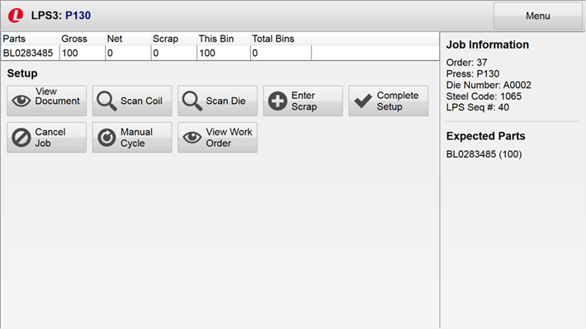

Touch here to scan the die for the job. **This action is required**.

Touch here when you have completed setup activity for the job.

Touch here to view documents associated with setting up and preparing the press. **This action is required.**

Touch here to scan the coil for the job. **This action is required.**

Touch here to identify any scrap that has been generated during the setup process.

The second row of buttons in the ***Setup*** menu contain utility tasks that enable you to complete the setup process.



Touch here to display the station menu.

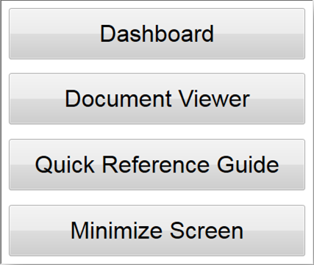

Touch here to view any tasks or preventive maintenance that must be performed.

Touch here to cancel the job. **Authorized personnel only will have access to   
this button.**

Touch here to enter the number of cycles that have been completed.

# The Station Menu

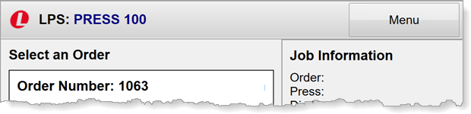The **Station Menu** is available by touching the **Menu** button visible in the upper right corner of the screen.

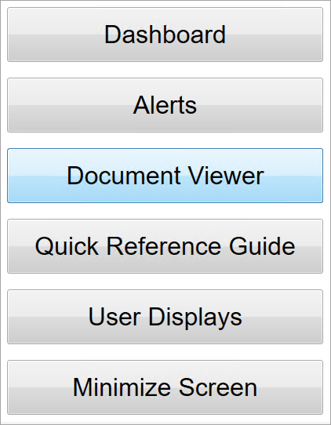It provides access to additional application functions:

* **Dashboard**. Touch to view station production information in a dashboard.
* **Alerts**. Touch to display a collection of Andon call buttons.
* **Document Viewer**. Touch to open the document viewer to review documents associated with the station.
* **Quick Reference Guide**. Touch to open the user documentation for the application.
* **User Displays**. Touch to select a default user display.
* **Minimize Screen**. Touch to minimize the user interface to display four different views.

## Dashboard

Touch the **Dashboard** option in the station menu to view the station dashboard:

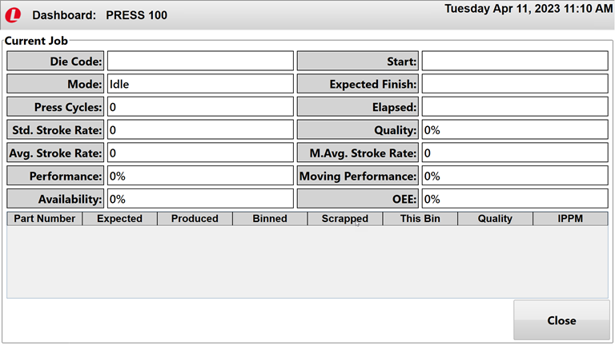

The ***Dashboard*** is displayed automatically after 15 seconds of press inactivity. Touch the ***Dashboard*** to return to the user display. A brief description of the fields in the ***Dashboard*** follows.

| Field | Explanation |
| --- | --- |
| Die Code | Code identifying the die currently on the press. |
| Start | Date and time the current job started. |
| Mode | Operating mode. Idle, Setup, Production, Down. |
| Expected Finish | Day, date, year, time the job is expected to finish. |
| Press Cycles | Number of cycles currently completed for the job. |
| Elapsed | Amount of time the current job has been in progress. |
| Std. Stroke Rate | The number of strokes per minute the press can perform. |
| Quality | (Parts Produced – Scrap) / Parts Produced. Shown as a percentage. |
| Avg. Stroke Rate | Average number of strokes the press takes to complete the entire job. |
| M. Avg Stroke Rate | The actual average number of strokes calculated using the last N cycles, where N is configurable per press, shown as a percentage. |
| Performance | Average Stroke Rate / Standard Stroke Rate. Calculated for the entire job. Shown as a percentage. |
| Moving Performance | Average Stroke Rate / Standard Stroke Rate. Calculated using the last N cycles, where N is configurable per press. Shown as a percentage. |
| Availability | Press availability as a percentage. |
| OEE | OEE percentage. |
| Part Number | Part number being produced by the current job. |
| Expected | Number of parts expected to be produced by the current job based on the part and die configuration selected. |
| Produced | Total number of parts produced, including binned and scrapped parts. |
| Binned | Parts that have been produced and binned for the current job. |
| Scrapped | Parts that have been produced and scrapped for the current job. |
| This Bin | Number of parts present in the current bin. |
| Quality | (Parts Produced – Scrap) / Parts Produced. Shown as a percentage. |
| IPPM | = (Scrap / Parts Produced) * 1,000,000 |

## Alerts

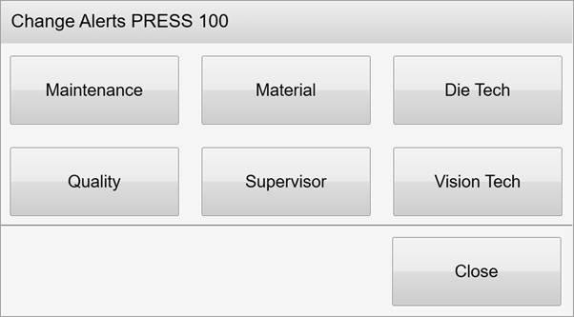

## Document Viewer

Touch **Document Viewer** to view the Choose Document window. This window enables you to filter available documents by system elements: Station, Press, Die, Die Config, and Part. In the following example, documents are being filtered by station and press.

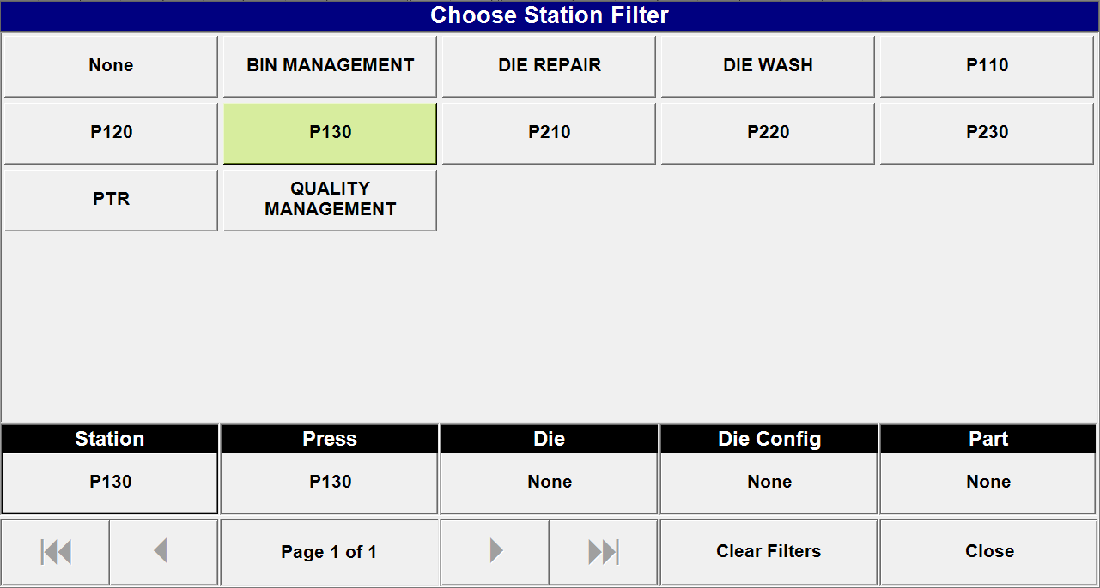`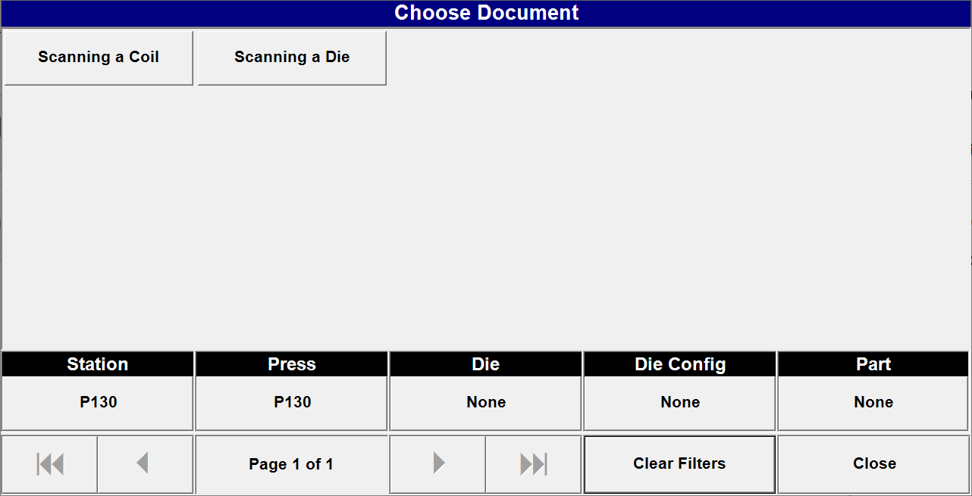

Elements that aren’t being filtered display **None** in their filter button.

Touch an option in the filter window. The selection is displayed in the filter button.

Touch a filter button here to view all options.

Touch a document name here to view the document.

Touch here to view all documents configured for the engine.

Touch here to close the window.

## Quick Reference Guide

Touch **Quick Reference Guide** in the menu to display online help for LPS3.

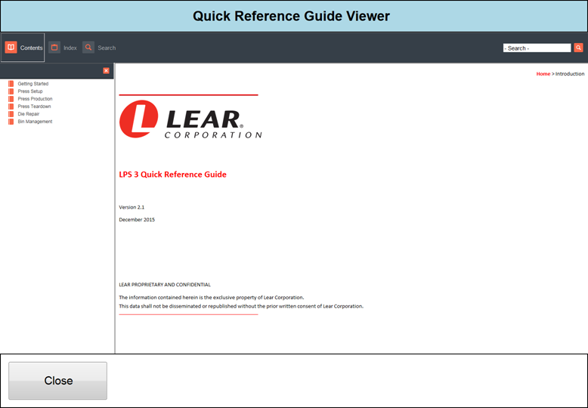

# User Display

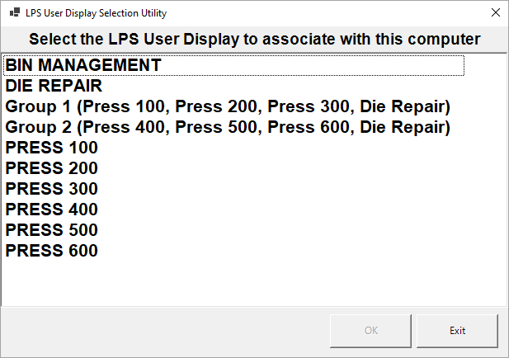

# Viewing Documents

You must view any documents that have been associated with setting up the station.

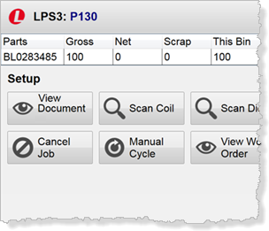

1. Touch **View Documents** in the ***Setup*** menu to display the ***View Documents*** screen.
2. Touch a document button to view the associated document.
3. The ***Document Viewer*** displays the document.
4. Touch close to return to the ***View a Document*** page.
5. Touch **Back** to return to the ***Setup*** menu.

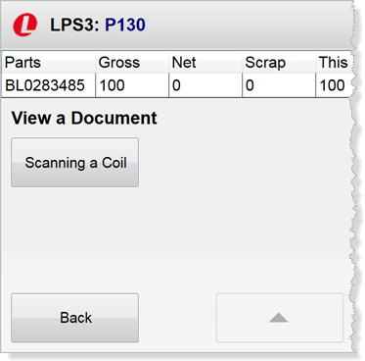

**2**

**1**

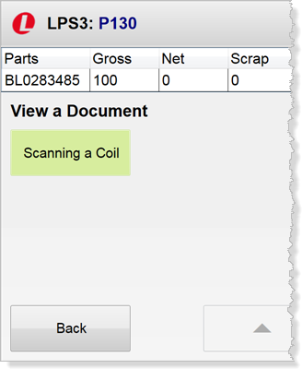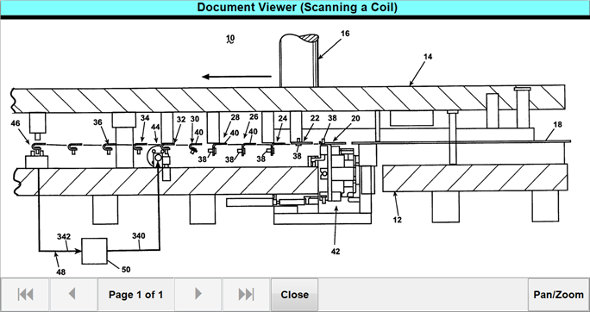

**5**

**4**

**3**

Viewed documents buttons change color.

# Using the Document Viewer

Below is a sample image inside the ***Document Viewer***.

The document name is displayed here. The document name and button label are the same.

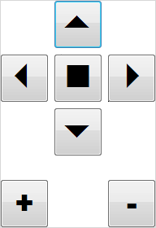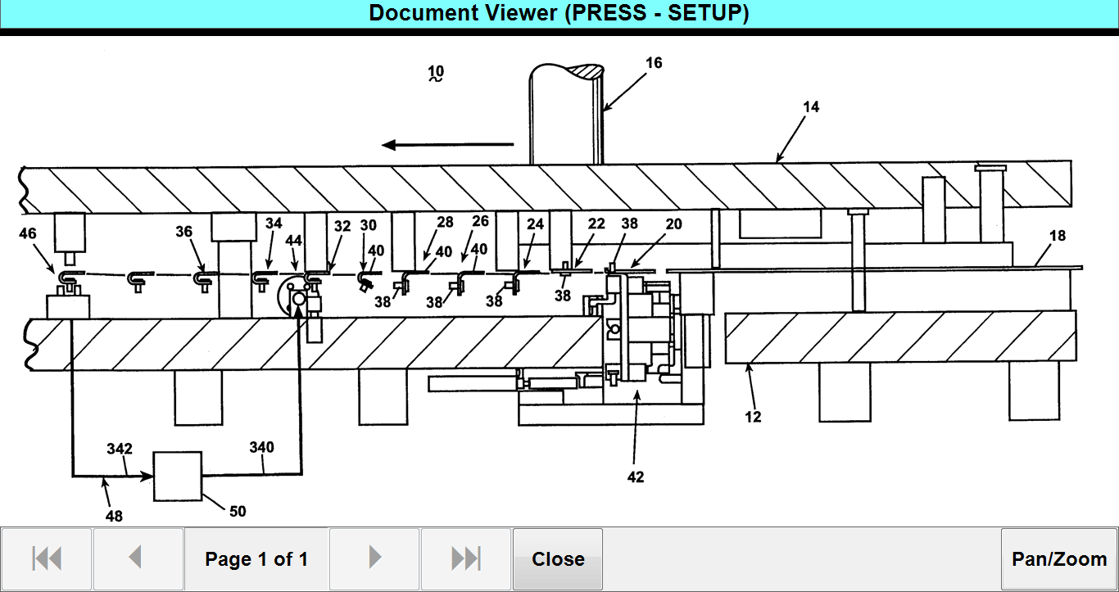

Touch here to start the pan/zoom feature.

Use the arrows, when available, to view additional document pages.

* Touch an arrow to move in that direction.
* Touch the square to reset the document.
* Touch the plus sign (+) to zoom in.
* Touch the minus sign (-) to zoom out.

# Scanning Coils

You must scan the coil you are using for the job.

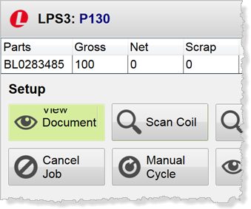

1. Touch **Scan Coil** in the ***Setup*** menu to display the ***Scan a Coil*** screen.
2. Scan the coil. A green check mark is displayed.

* If an incorrect value is scanned, an error message and red X are displayed.

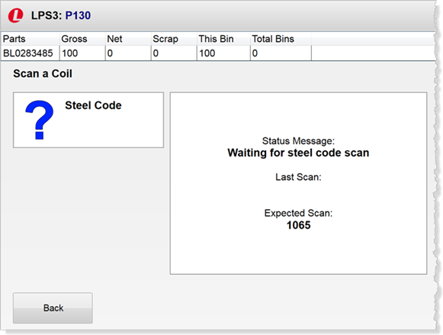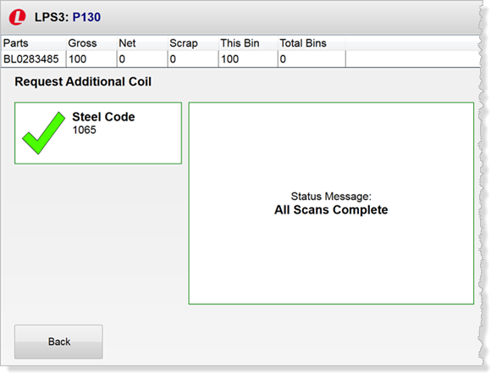**2**

**2**

**1**

# Scanning Dies

You must scan the die you are using for the job.

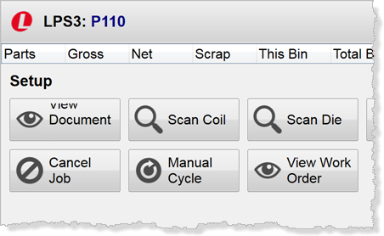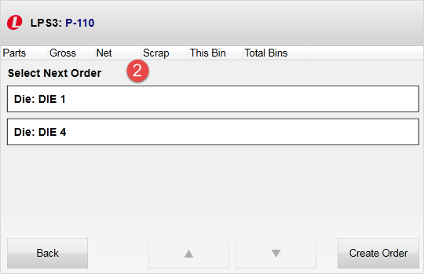

1. Touch **Scan Die** in the ***Setup*** menu to display the ***Scan a Die*** screen.
2. Scan the label. A message and a green check mark are displayed when the scan is successful.
   * If an incorrect value is scanned, an error message and red X are displayed.

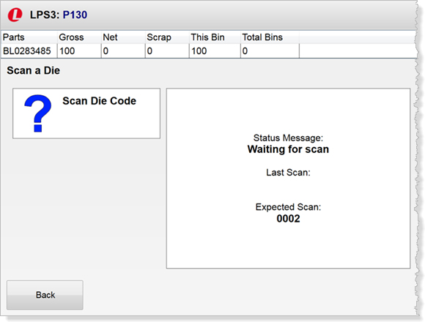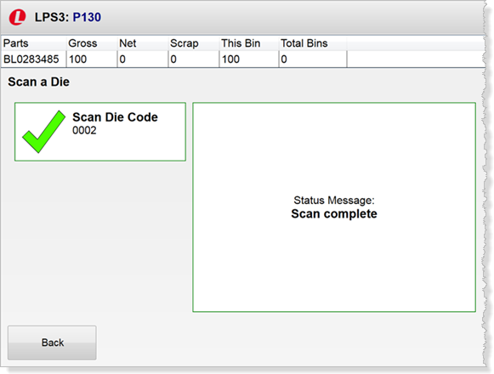

**2**

**1**

# Entering Scrap

Scrap may be generated during setup and production. Use the **Enter Scrap** action available on the ***Setup*** and ***Production*** menus to specify the number of scrap parts created. You can also enter scrap when creating bins.

1. Touch **Enter Scrap** in the ***Setup*** or ***Production*** **menu** or **Scrap Quantity** in the ***Create Bins*** screen to display the ***Enter Scrap*** screen.

The screen displays a button for each part included in the job.

1. Touch a part number. The ***Enter Scrap and Select Scrap Code*** screen is displayed.

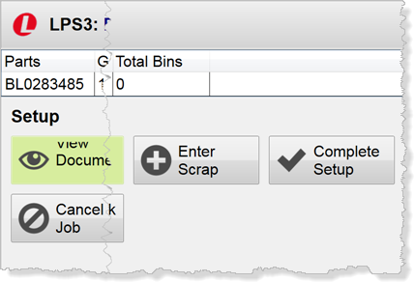

**1**

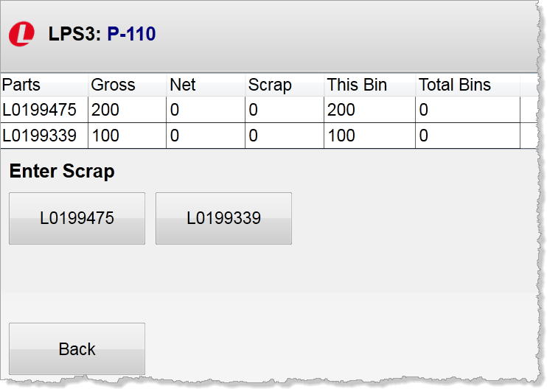

As setup cycles are run, a table similar to this one updated. In this example, two distinct parts are created in each cycle, with one of the parts generating two pieces in each cycle.

**2**

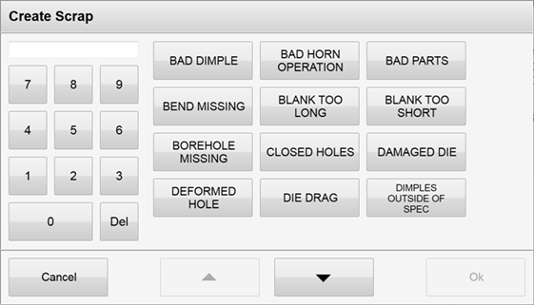When you enter scrap, you must also enter a scrap code. A button is displayed in the ***Enter Scrap and Select Scrap Code*** screen for each available scrap code.

1. Touch numbers on the keypad to enter the scrap quantity for the selected part.
2. Touch a scrap code button to identify the reason for the scrap.
3. Touch the **Complete** button, which is now available, to return to the ***Enter Scrap*** screen.

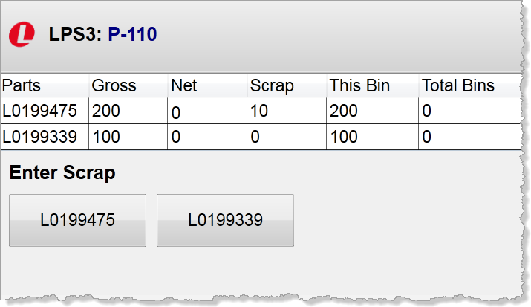

**3**

**4**

**5**

The “Scrap” field of the table now displays, or is incremented by, the value you entered in step 4.

To “cancel” your entries, touch **Back** instead of **Complete** to return to the ***Enter Scrap*** screen. The table is unchanged.

.

# Completing Setup

The **Complete Setup** button allows you to indicate that all required setup activity for the order is completed. You must have viewed documents, scanned the coil, and scanned the die.

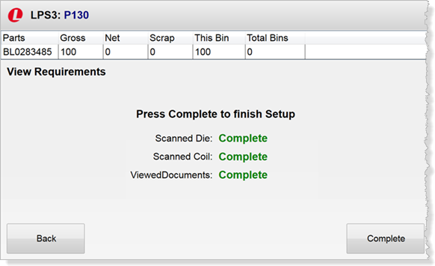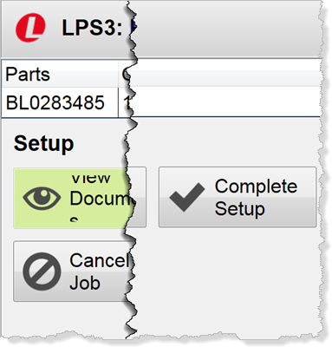

**2**

**1**

1. Touch **Complete Setup** on the ***Setup*** menu to display the V***iew Requirements*** screen.
2. Touch the **Completed** button in the lower right corner to continue. The ***Production*** menu is displayed.

The screen lists the three required actions and their status as “Completed.”

Touch here to continue. The ***Production*** menu is displayed.

You must perform all required steps to complete setup. If you touch the **Complete Setup** button before they are completed, a ***Complete Setup*** screen similar to the one below is displayed. Notice the screen includes a message that indicates you must complete setup, “Not Completed” is displayed in red for each incomplete step, and the **Complete** button is not available. Return to the ***Setup*** menu and perform the incomplete tasks(s).

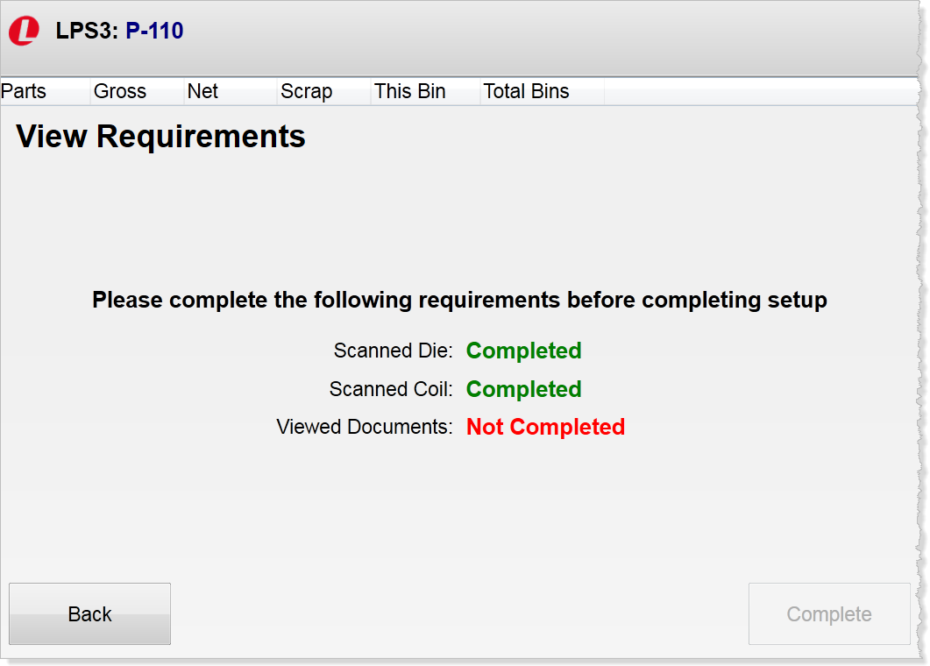

Touch here to return to the ***Setup*** menu to complete the setup tasks.

“Not Completed” is displayed in red.

The message indicates you must complete setup.

Button is not available.

# Cancelling the Job

**Authorized personnel only** can cancel a job currently being set up using the **Cancel Setup** button in the ***Setup*** menu. Cancelling setup returns the station to **Idle** mode.

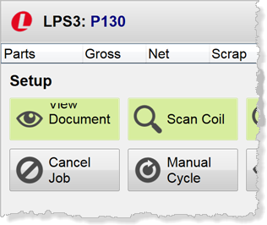

1. Touch **Cancel Job** on the ***Setup*** menu. The ***Cancel Job*** screen is displayed.
2. Touch **OK** to cancel the job. The ***Idle*** menu is displayed.

**1**

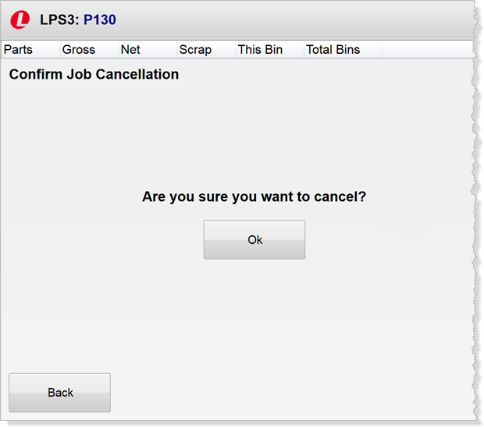

**2**

# Entering Cycles

The **Manual Cycle** function in the ***Setup*** and ***Production*** menus is available in the event of a communication failure between the application and the press.

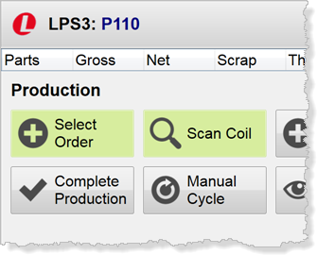

1. Touch **Manual Cycle** in the ***Setup*** or ***Production*** menu. The ***Manual Cycle*** screen is displayed.
2. Touch **Enter Cycles.** A keypad is displayed.
3. Enter the current number of cycles on the press and touch **Enter**.

The “Gross” field is incremented by the difference between the cycle quantity you enter in the keypad and the most recent value in the “Gross” field.

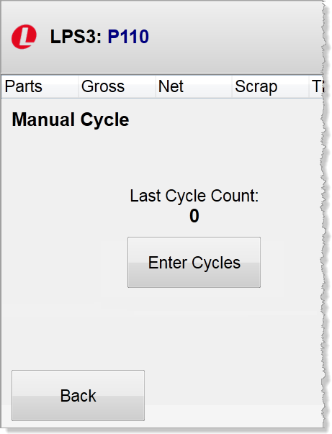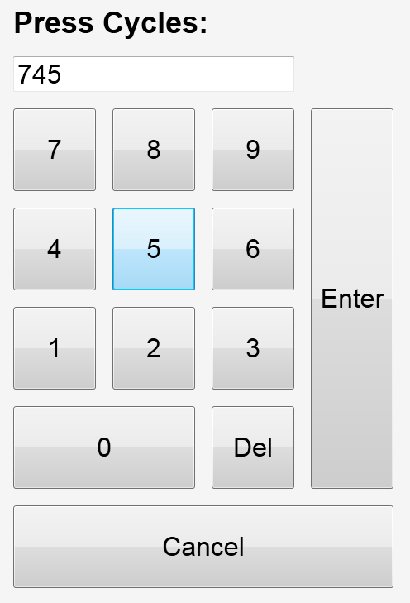

**3**

**2**

**1**

# The Production Menu

The ***Production*** menu is displayed when you touch the **Complete** **Setup** button in the ***Setup*** menu. The top row of the menu includes buttons that enable you to keep the station going for the current job, including: selecting another order, adding additional coils to the press, and creating bins for the parts being produced.

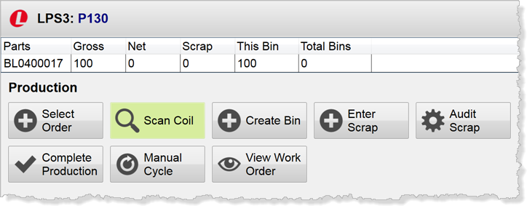

You are in **Production** mode.

Touch here to adjust scrap quantities and codes and print scrap labels.

Touch here to enter scrap quantities produced during the production cycle.

Touch here to create a bin for the current job.

Touch here to scan additional coils for the current job.

Touch here to select the next order for the station.

The second row of buttons in the ***Production*** menu are utility tasks that enable you to complete the production process for the current job.



Touch here to view any tasks or preventive maintenance that must be performed.

Touch here to manually enter the number of cycles that have been completed.

Touch here to indicate production is complete.

# Selecting the Next Order

As you near completion of the current job in **Production** or when you enter **Teardown** mode, you may want to select the next order for the station. This ensures the station will move into **Setup** mode for the next job when the current job is complete. If you do not select the next order, the station moves into **Idle** mode when the current order finishes. A station can have only one job in **Production** and one job outstanding.

1. Touch the **Select Next Order** button in the ***Production*** or **Teardown** menu.
2. Touch the next order for the station in the ***Select Next Order*** screen. The ***Order Number*** pop-up window is displayed.

* If the next order has been selected, a message is displayed. Touch **Back** to return to the menu.

1. Click **OK** in the ***Order Number*** pop-up. The ***Production*** menu is displayed.
2. An “Outstanding Requests” line referencing the next job is added to the “Job Information” section of the screen.

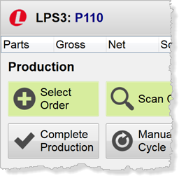

**2**

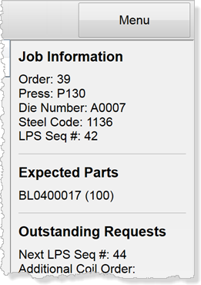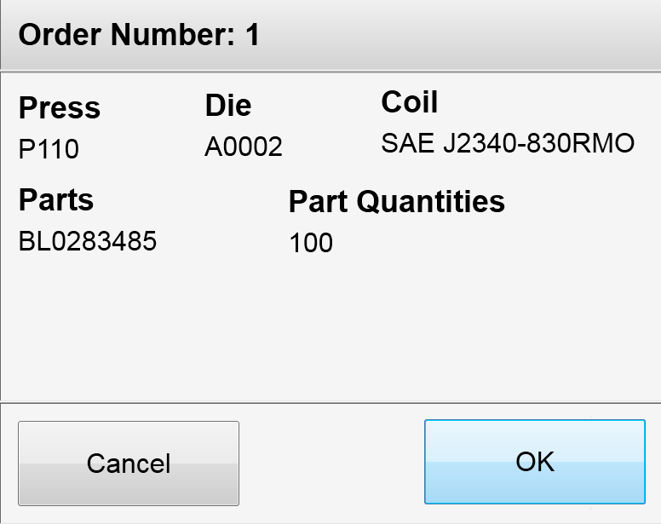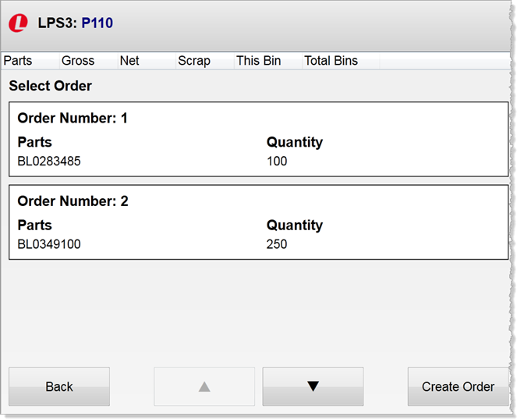

**4**

**3**

**1**

# Creating Bins

The **Create Bins** button is available on the ***Production*** menu to allow you to identify the bins for the part(s) currently being produced.

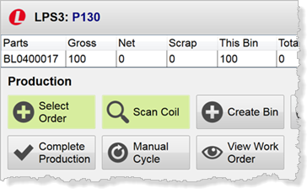

1. Touch the **Create Bin** button in the ***Production*** menu. The ***Create Bin*** screen is displayed. It contains a row for each part to be binned.
2. Touch the **Bin Size** button, which defaults to the standard pack size for the part.

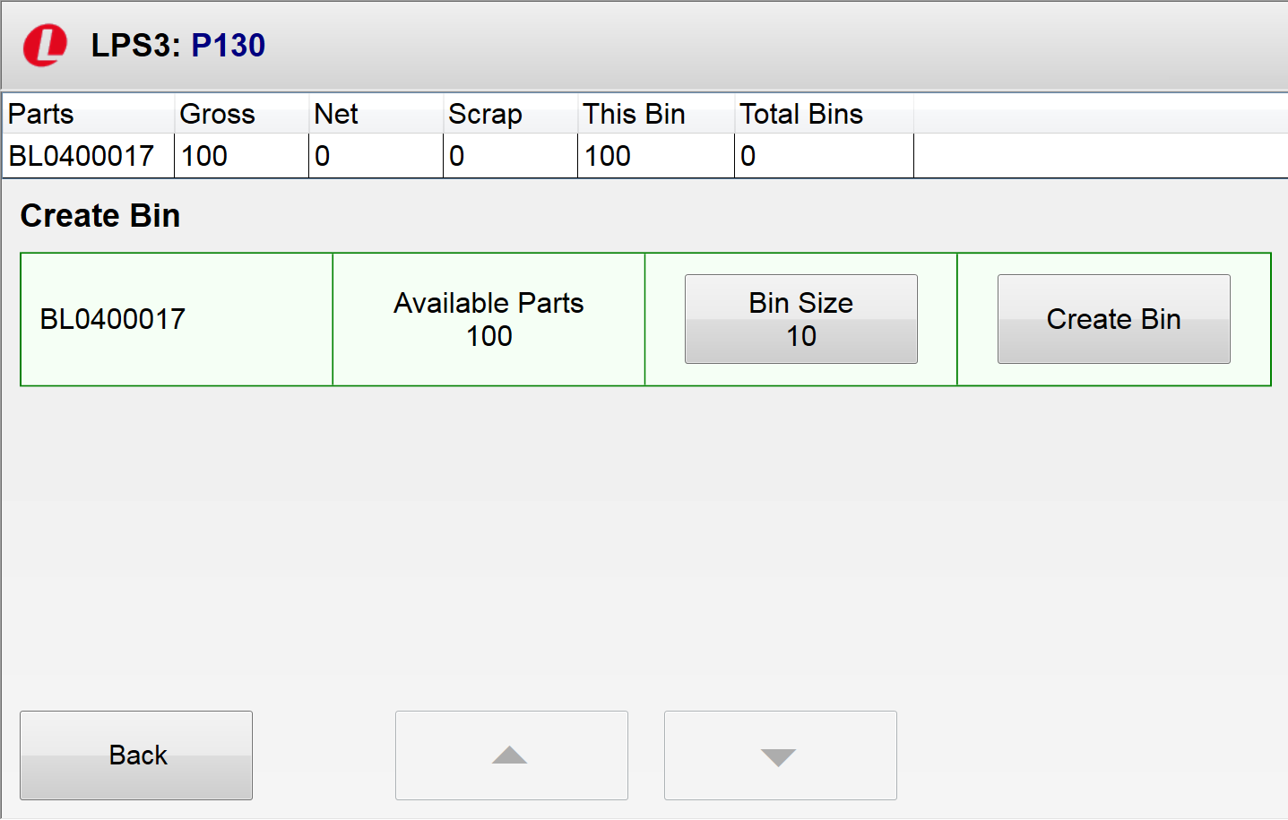

**2**

**1**

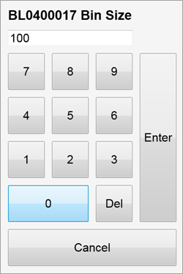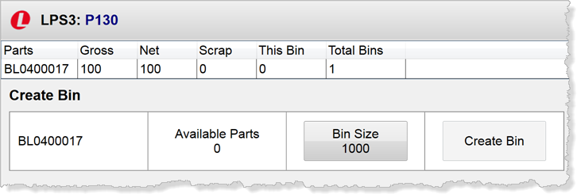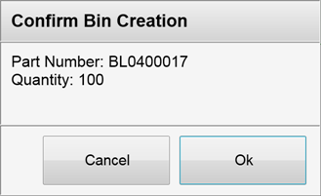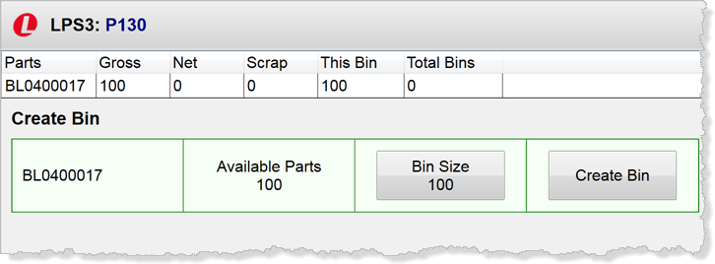

**7**

**6**

**4**

**5**

**3**

1. Enter the bin size in the keypad that is displayed and click **Enter**.
2. The **Create Bin** screen is returned. The **Bin Size** button changes to the value from the keypad.
3. Touch **Create Bin**.
4. Click **OK** when prompted.
5. The ***Create Bin*** screen is returned. The Available Parts field, **Bin Size** button, and ***Production Summary Table*** are updated.

You cannot enter a bin quantity larger than the number of available parts. If you try, the value will default to the Available Parts value.

Scrap Quantity button to enter any scrap, if necessary. See “*Entering Scrap*” for additional instructions, if needed.

# Auditing Scrap

The **Audit Scrap** function of the ***Production*** menu allows you to adjust scrap quantities and codes, print labels, and optionally specify buyoffs.

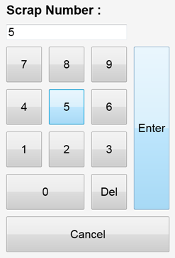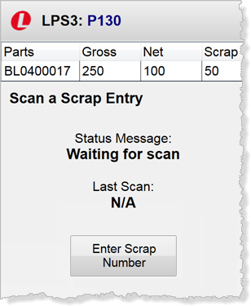

**1**

1. Touch the **Audit Scrap** button in the ***Production*** menu. The ***Scan a Scrap Entry*** screen is displayed.
2. Touch the **Enter Scrap Number** button.
3. Enter the scrap number in the keypad. Touch **Enter**. The ***Audit Scrap*** screen is displayed.
4. Touch **Adjust Scrap** to display the ***Edit Scrap*** screen to change the quantity or code.
5. Touch **Print Label** to generate scrap labels.
6. Touch buyoff buttons as appropriate.
7. Click **Commit** to save the entries.

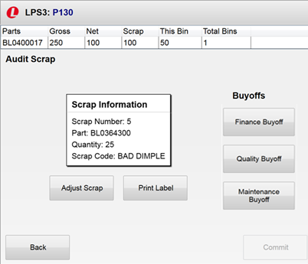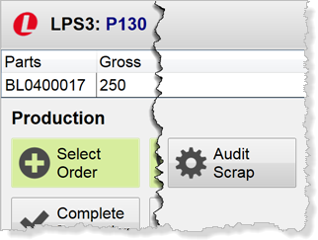

**6**

**7**

**5**

**5**

**4**

**2**

**3**

# Completing Production

Use the **Complete Production** button on the **Production** menu when the current job is complete and all parts have been binned.

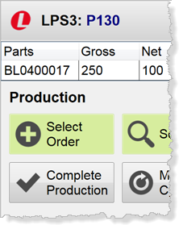

1. Touch **Complete Production** on the ***Production*** menu. The ***Complete Production*** screen is displayed.
2. Touch **Complete**. The ***Teardown*** menu is displayed

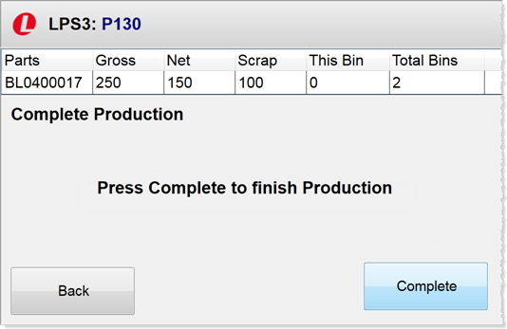

**2**

**1**

# The Teardown Menu

The ***Teardown*** menu is displayed when you touch the **Complete** **Production** button in the ***Production*** menu. The actions available from this menu enable you to perform tasks associated with maintaining the station and die between jobs.

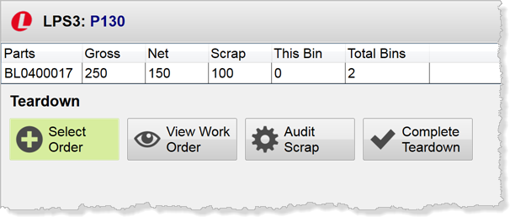

You are in **Teardown** mode.

Touch here to adjust scrap quantities and codes and print scrap labels.

Touch here when all Teardown activity is complete.

Touch here to view any tasks or preventive maintenance that must be performed.

Touch here to select the next order for the station. If an order was selected in **Production** mode, this button is green.

# Viewing Work Orders

The **View Work Order** action available in the ***Teardown*** menu allows you to view any maintenance activities that must be performed on the station or die. This includes scheduled preventative maintenance and routine tasks that are completed each time the die is used.

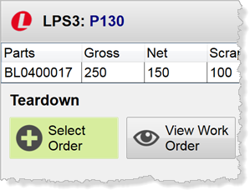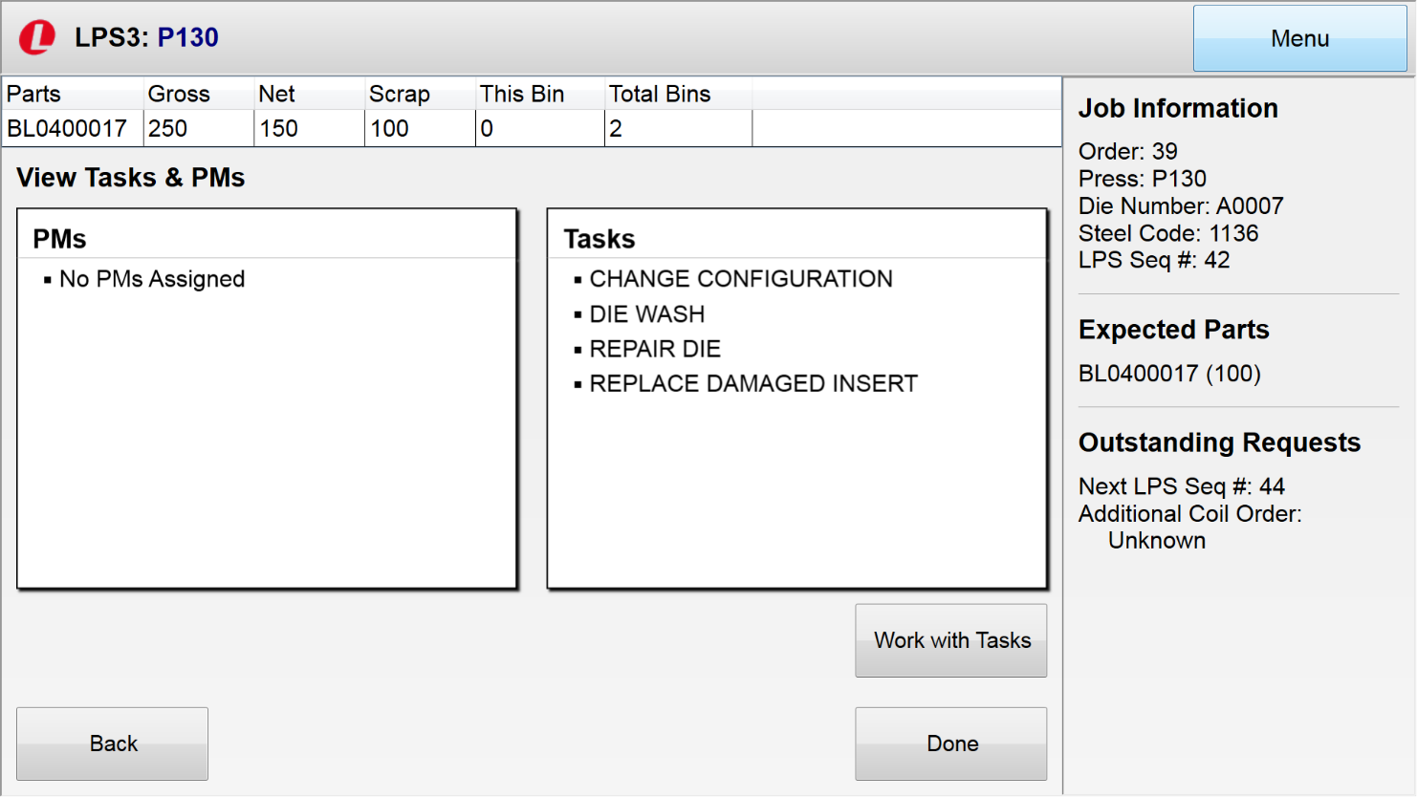

**2**

**1**

1. Touch **View Work Order** in the ***Teardown*** menu. The ***View Work Orders*** screen is displayed.
2. Touch **Work with Tasks** to display the ***Select Work Orders Tasks*** screen.

# Working with Tasks

The ***Select Work Order Tasks*** screen displays the work order tasks associated with the die used for the current job. Tasks to be completed have a “Pending” status and are completed at a repair station. You can select additional tasks as necessary.

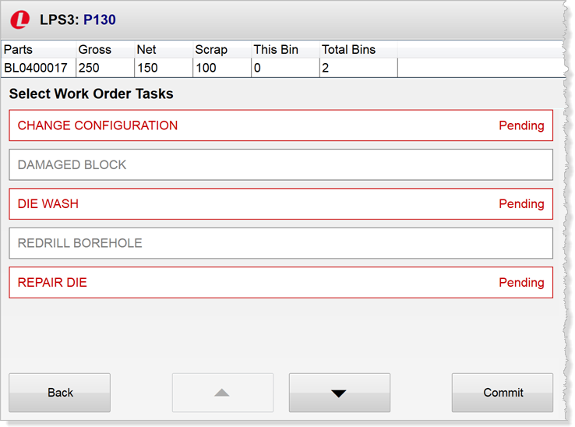

Review the selected tasks. If the pending tasks are correct, touch Back to return to the ***View Work Order*** screen.

To add a new task:

1. Touch the task name. The task color changes and status changes to “Added.”
2. Touch **Commit** to change the task to “Pending” and return to the ***View Work Order*** screen.

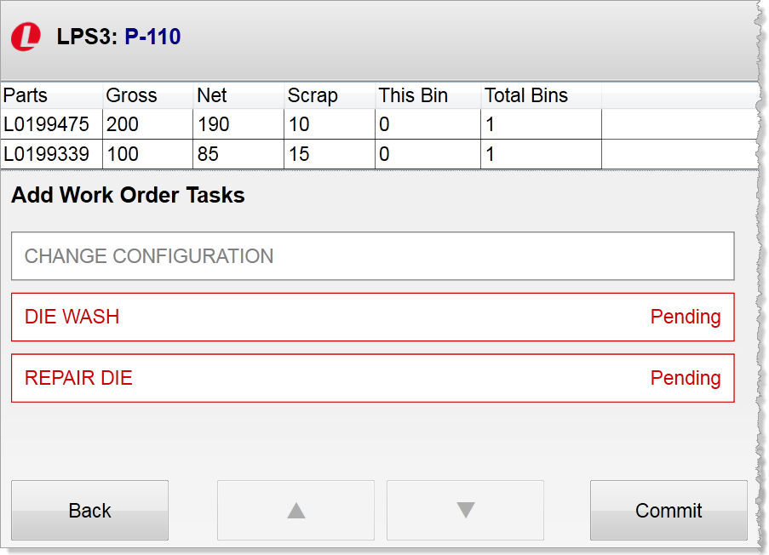

**2**

**1**

# Completing Teardown

Use the **Complete Teardown** button on the ***Teardown*** menu when all teardown activity has been completed.

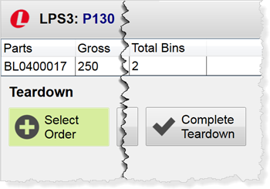

1. Touch **Complete Teardown** on the ***Teardown*** menu. The ***Complete Teardown*** screen is displayed.
2. Touch **Complete**.
   * If another order has been selected, the ***Setup*** menu is displayed.
   * If another order has not been selected, the ***Idle*** menu is returned.

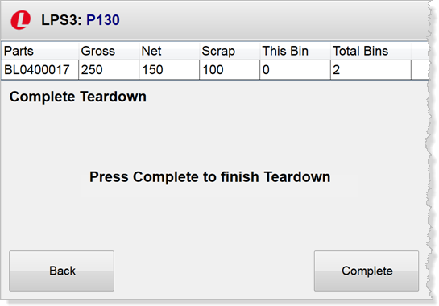

**2**

**1**

# Completing Work Orders

Work orders are completed at a repair station. Dies needing work are listed in the left side of the repair station screen. Buttons are available to add and close work orders.

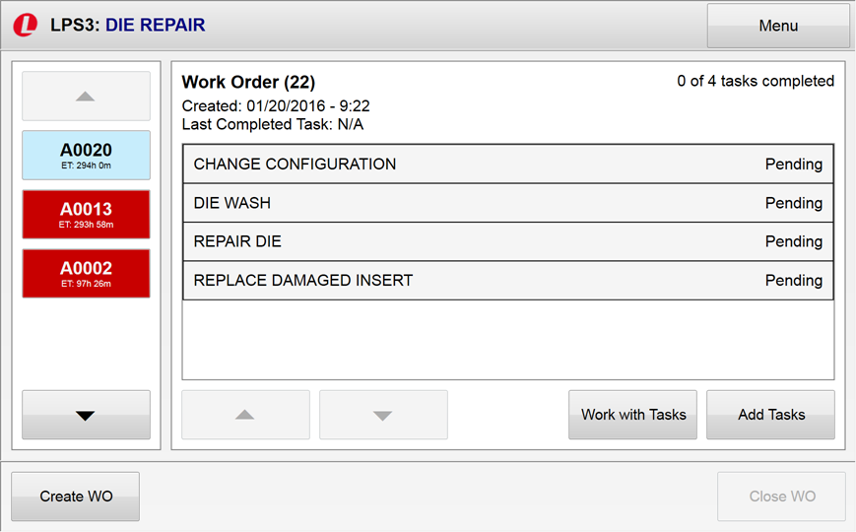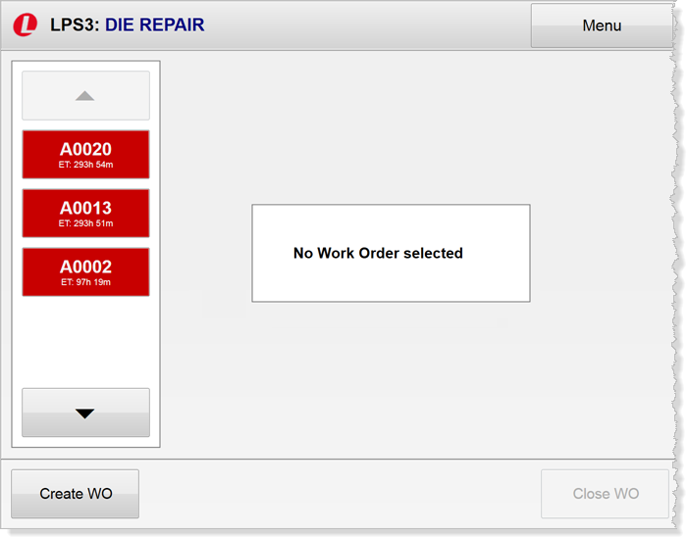C:\Users\vwhitehorne\AppData\Local\Temp\SNAGHTML4c4696a4.PNGC:\Users\vwhitehorne\AppData\Local\Temp\SNAGHTML4c44def9.PNG

**5**

**4**

**3**

**2**

**1**

1. Touch the die being repaired in the left column. Repair tasks are displayed.
2. Touch **Work with Tasks** to work with assigned tasks.
3. Touch **Add Tasks** to add new tasks to the work order.
4. Touch **Create WO** to create a new work order.
5. Touch **Close WO** to close a work order.

# Working with Assigned Tasks

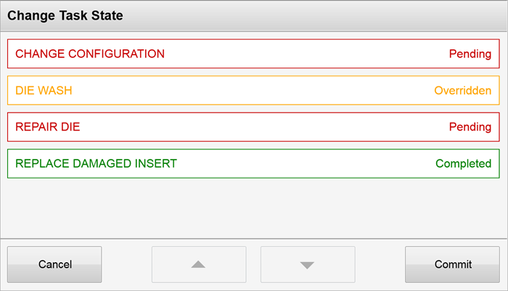The **Work with Tasks** button in the repair station screen enables you to update the status of assigned tasks. Touch the button to display the ***Change Task State*** screen.

**2**

**1**

1. Touch a task to toggle its status. Options are:

* **Pending**
* **Completed**
* **Overridden**

1. Touch **Commit** to save your entries.
2. The repair station screen is returned. Tasks with a changed status are displayed in the new status color.

# Adding Tasks

Touching the **Add Tasks** button in the repair station screen enables you to add preventative maintenance and work order tasks to at the selected work order. The ***Add Tasks*** screen is displayed.

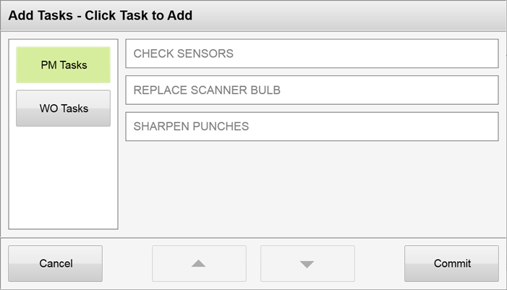

1. Touch a task type to view tasks for the selected die.
2. Touch an unassigned task to toggle its status to “Adding” and change the task color to gray. .
3. Touch **Commit** to save the tasks to the work order.
4. Update the status of the assigned tasks when appropriate.

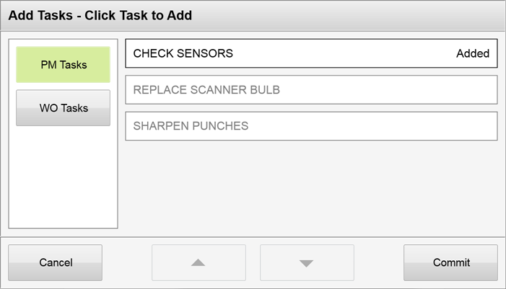

**3**

**2**

**1**

# Closing a Work Order

When all tasks for a work order are complete, the **Close WO** button in the lower right corner of the repair screen is available. Touch the button to close the work order for the selected die.

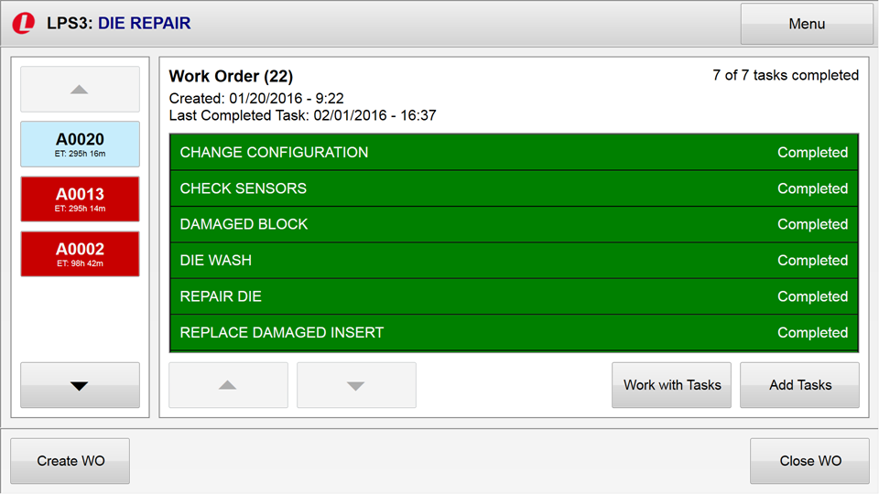

Touch here to close the work order. The button is enabled when all tasks are completed.

# Adding a Work Order

You can add work orders for available dies using the **Add WO** button on the repair station screen.

1. Touch **Create WO** in the lower left corner of the ***Die Repair Station*** screen**. You are prompted to select a die.**
2. Touch the die to which you are adding a work order.

A button is added to the bottom of the list in the left panel of the screen.

1. Scroll to the die button.
2. Add tasks.

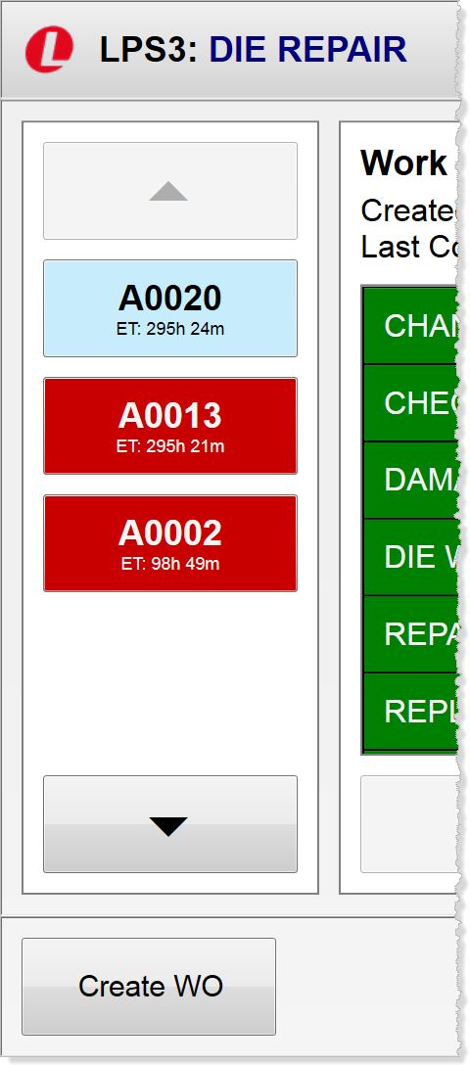

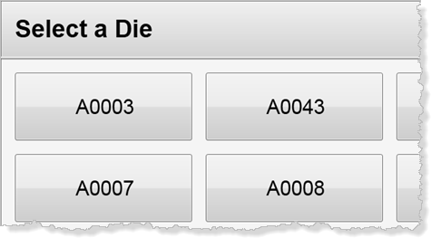

**2**

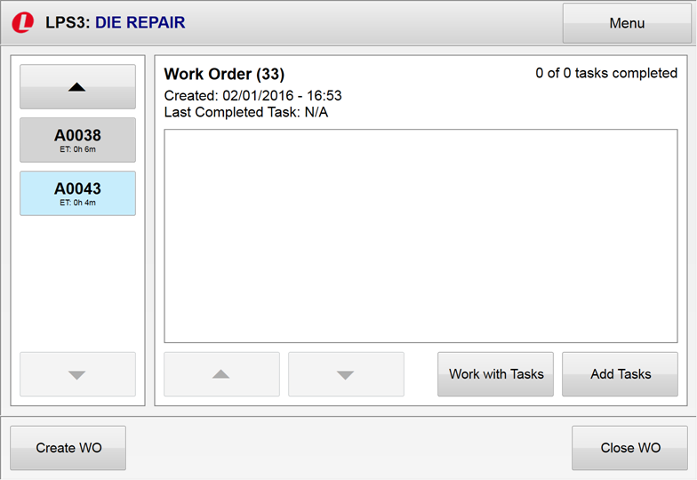

**3**

**4**

**1**

# Managing Bins

Bin management stations are available to manually process bin activity when communication with the press is unavailable. These stations display a menu similar to the following:

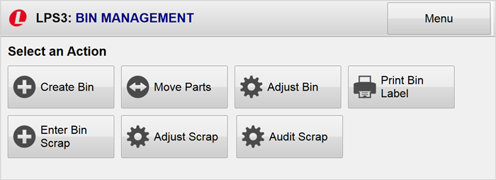

Touch here to create bins.

Touch here to adjust a bin quantity or state.

Touch here to record part movement among bins and print new bin labels.

Touch here to print a label for a selected bin.



Touch here to record scrap found in a bin as well as loose scrap.

Touch here to adjust a bin quantity or state.

Touch here to change change scrap quantity and code.

# Creating a Bin

The **Create Bin** button in the ***Bin Managemen***t menu allows you to create a bin for a selected press.

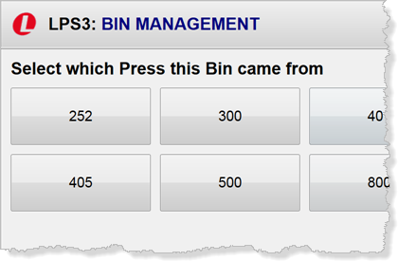

**1**

1. Touch the **Create Bin** button in the menu.
2. Touch the press for which you are creating a bin. Touch **Next**.
3. Enter the bin quantity and part stored in the bin. Touch **Next**.
4. Touch the state of the bin. Then touch **Next**.
5. Information about the bin is displayed. Touch **Print Label** to print a label for the new bin.
6. Touch **Complete** to return to the ***Bin Management*** menu.

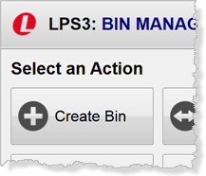

**2**

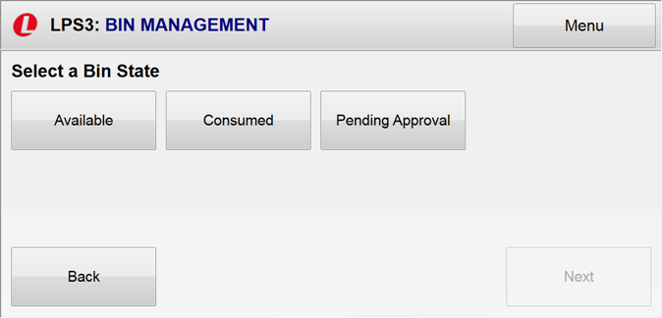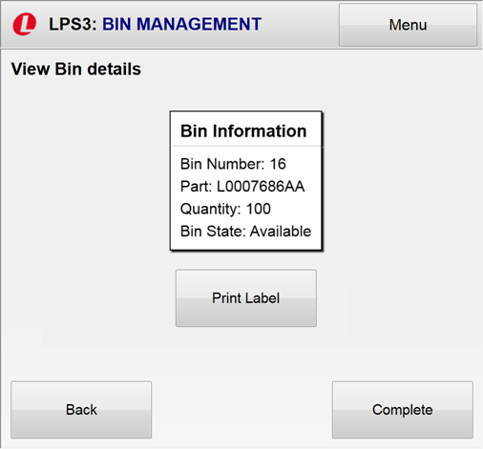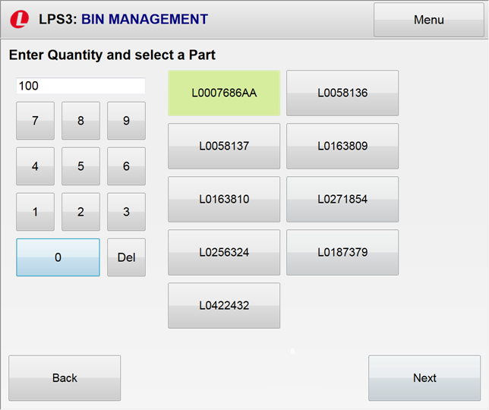

**6**

**5**

**4**

**3**

# Moving Parts between Bins

You can move parts among different bins using the **Move Parts** button.

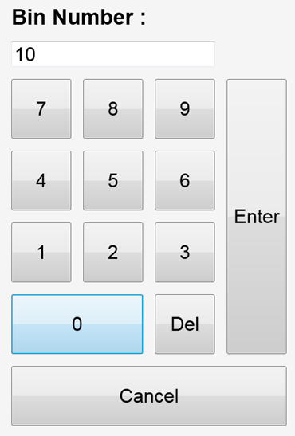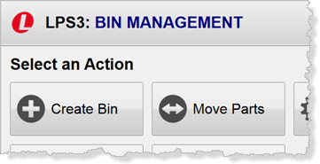

1. Touch the **Move Parts** bin.
2. Touch **Enter Bin Number.**
3. Enter the first bin in the keyboard that is displayed.
4. Touch **Enter Bin Number** again and enter the second bin number.

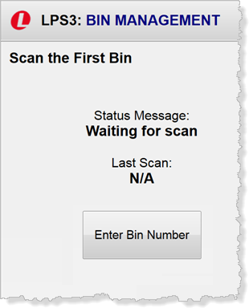

**3**

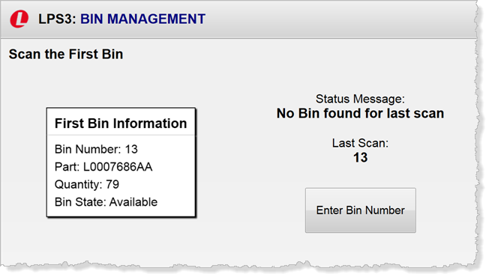

**4**

**21**

**1**

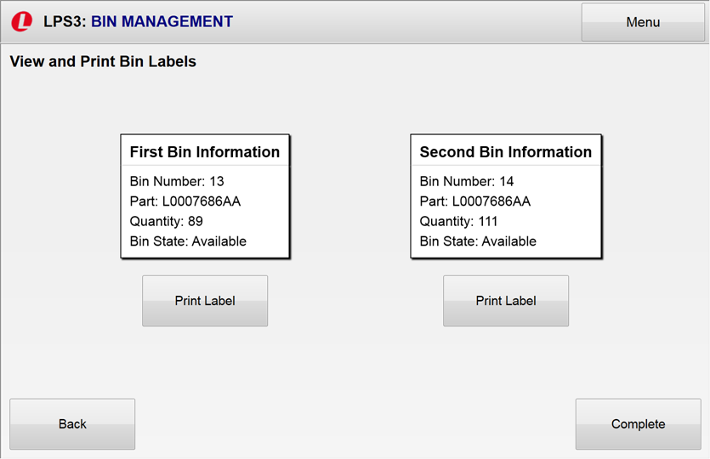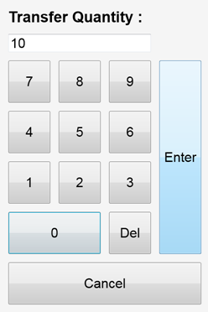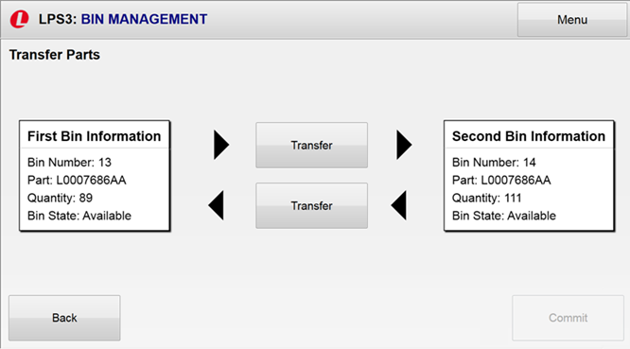

**9**

**87**

**6**

**7**

**5**

1. The ***Transfer Parts*** window is displayed. Touch a **Transfer** button.
2. Enter the quantity to transfer and touch **Enter**.
3. Touch **Commit.**
4. Touch **Print Label** to print new labels for the bins.
5. Touch **Complete** to return to the ***Bin Management*** menu.

# Adjusting Bin Size and State

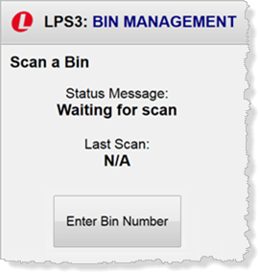Use the **Adjust Bin** button to change the size or state of a bin.

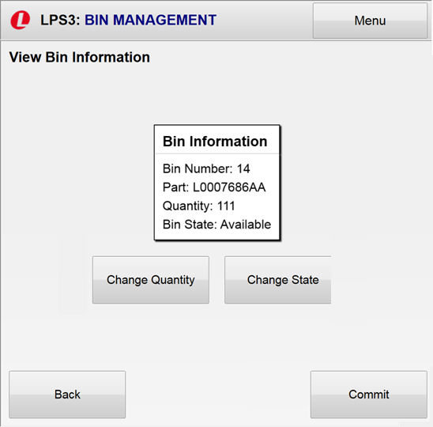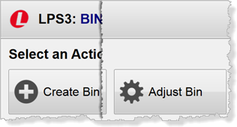

**31**

**21**

1. Touch the **Adjust Bin** button in the ***Bin Management*** bin. The ***Scan a Bin*** window is displayed.
2. Touch **Enter Bin Number.** A pop-up keypad is displayed.
3. Enter the bin number and touch **Enter**. Bin information is displayed.
4. To change the bin quantity, touch **Change Quantity.**
5. **E**nter the new quantity in the pop-up keypad.

**1**

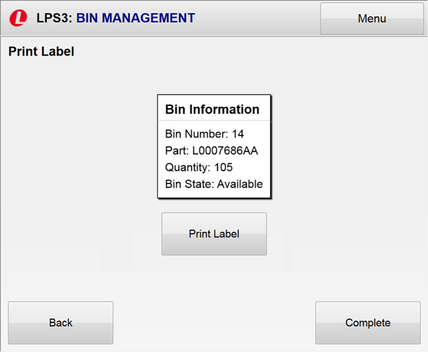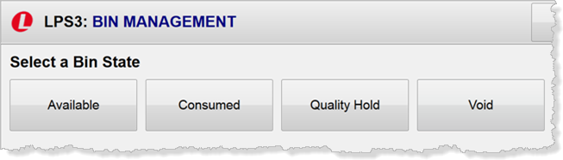

**8**

**9**

**7**

**6A**

**6B**

1. To change the bin state:
   1. Touch **Change State**.
   2. Select the new state.
2. Touch **Commit**. A new label is displayed.
3. Touch **Print Label** to print the new label.
4. Touch **Complete** to return to the menu.

# Printing a Bin Label

Touch the **Print Bin Label** in the ***Bin Management*** menu to print a label for a selected bin.

1. Touch **Print Bin Label**. The ***Scan a Bin*** window is displayed.
2. Touch **Enter Bin Number** to display a pop-up keypad.
3. Enter the bin number in the keypad and touch enter. A new label is displayed.
4. Touch **Print Label** to generate the label and return to the menu.

**1**

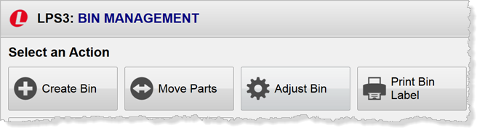

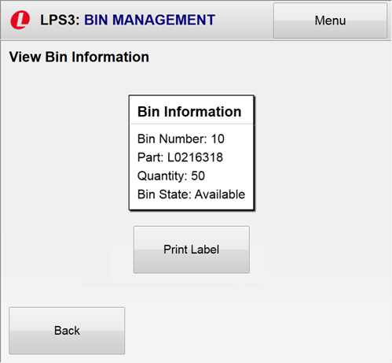

**3**

**2**

**4**

# Entering Bin Scrap

The **Enter Bin Scrap** option of the ***Bin Management*** menu enables you to track bin scrap and generate labels for the bin and scrap.

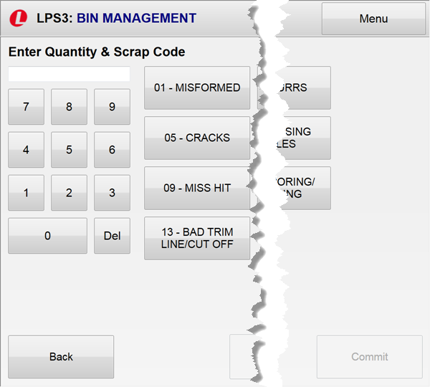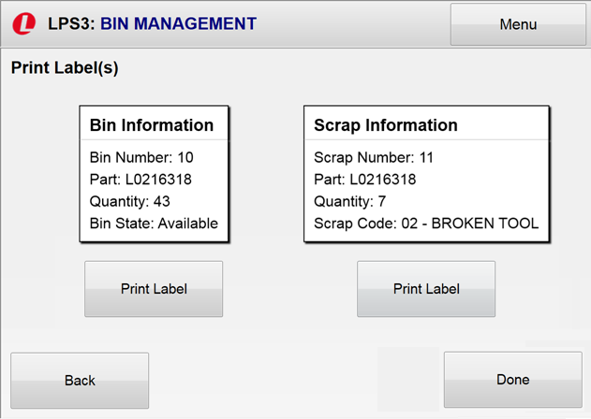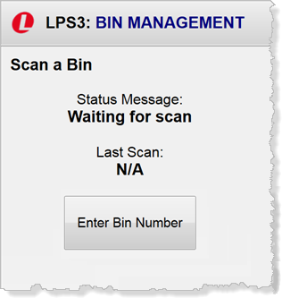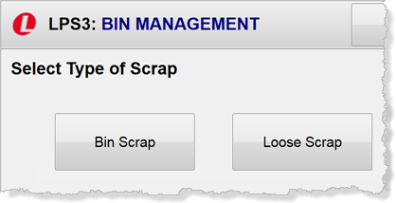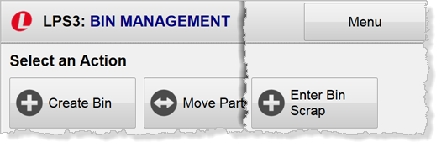

**5**

**6**

**7**

**3**

**4**

**2**

**1**

To enter bin scrap:

1. Touch **Enter Bin Scrap**. The ***Select Type of Scrap*** window is displayed.
2. Touch **Bin Scrap**. The **Scan a Bin** window is displayed.
3. Touch **Enter Bin Number** and enter the bin number in the pop-up keypad. You are prompted to enter the scrap quantity and code.
4. Enter the amount of scrap from the bin and touch a scrap code.
5. Touch **Commit**. New labels are displayed.
6. Touch **Print Label** to print the labels.
7. Touch **Done** to return to the ***Bin Management*** menu.

# Entering Loose Scrap

In addition to enter bin scrap, the **Enter Bin Scrap** option of the ***Bin Management*** menu enables you to track loose scrap and generate labels.



**2**

**1**

To enter loose scrap:

1. Touch **Enter Bin Scrap**. The ***Select Type of Scrap*** window is displayed.
2. Touch **Loose Scrap**.
3. Touch the press where the scrap was generated.
4. Select the scrap part number.
5. Enter the scrap quantity and reason.
6. Touch **Commit**. A new label is displayed.
7. Touch **Print Label** to print the new label.
8. Touch **Done** to return to the menu.

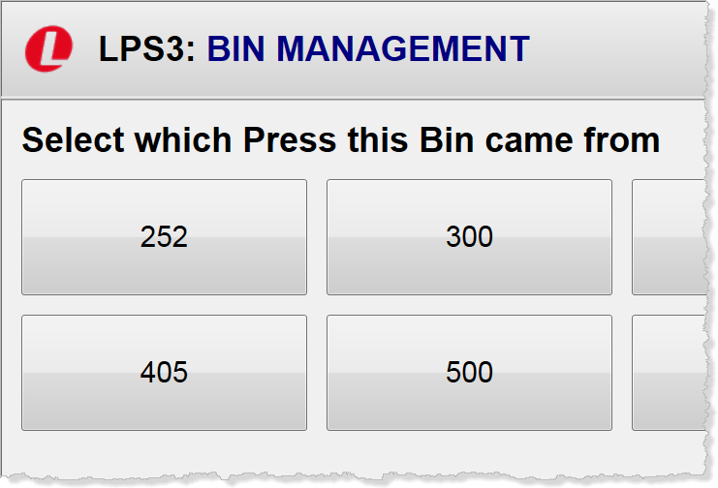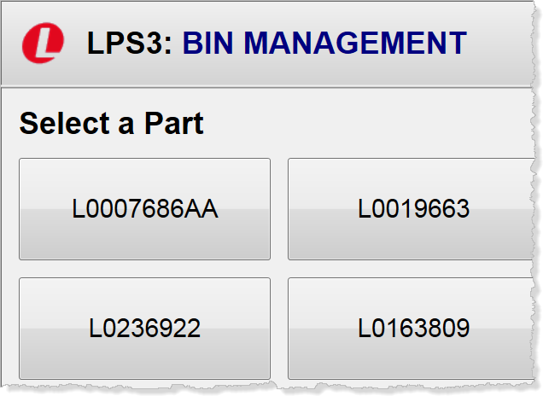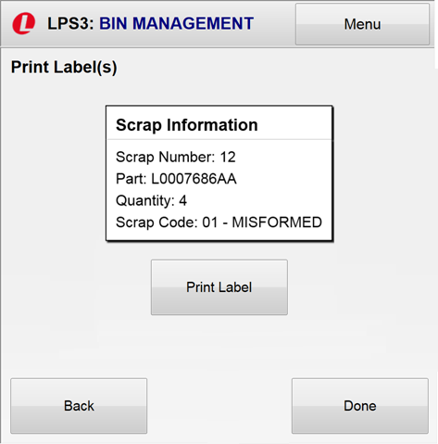

**8**

**7**

**6**

**5**

**4**

**3**